Phenix Payton
NET 2300
DBMigrate Milestone 2
4/19/26
Run start-engine.sh in the background:
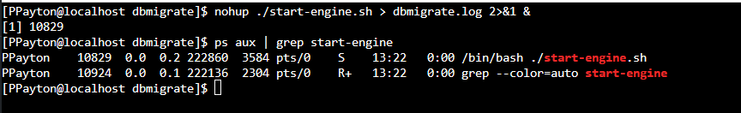
Several Linux Commands issued through frontend and logged to dbmigrate.log (shown using tail -f):
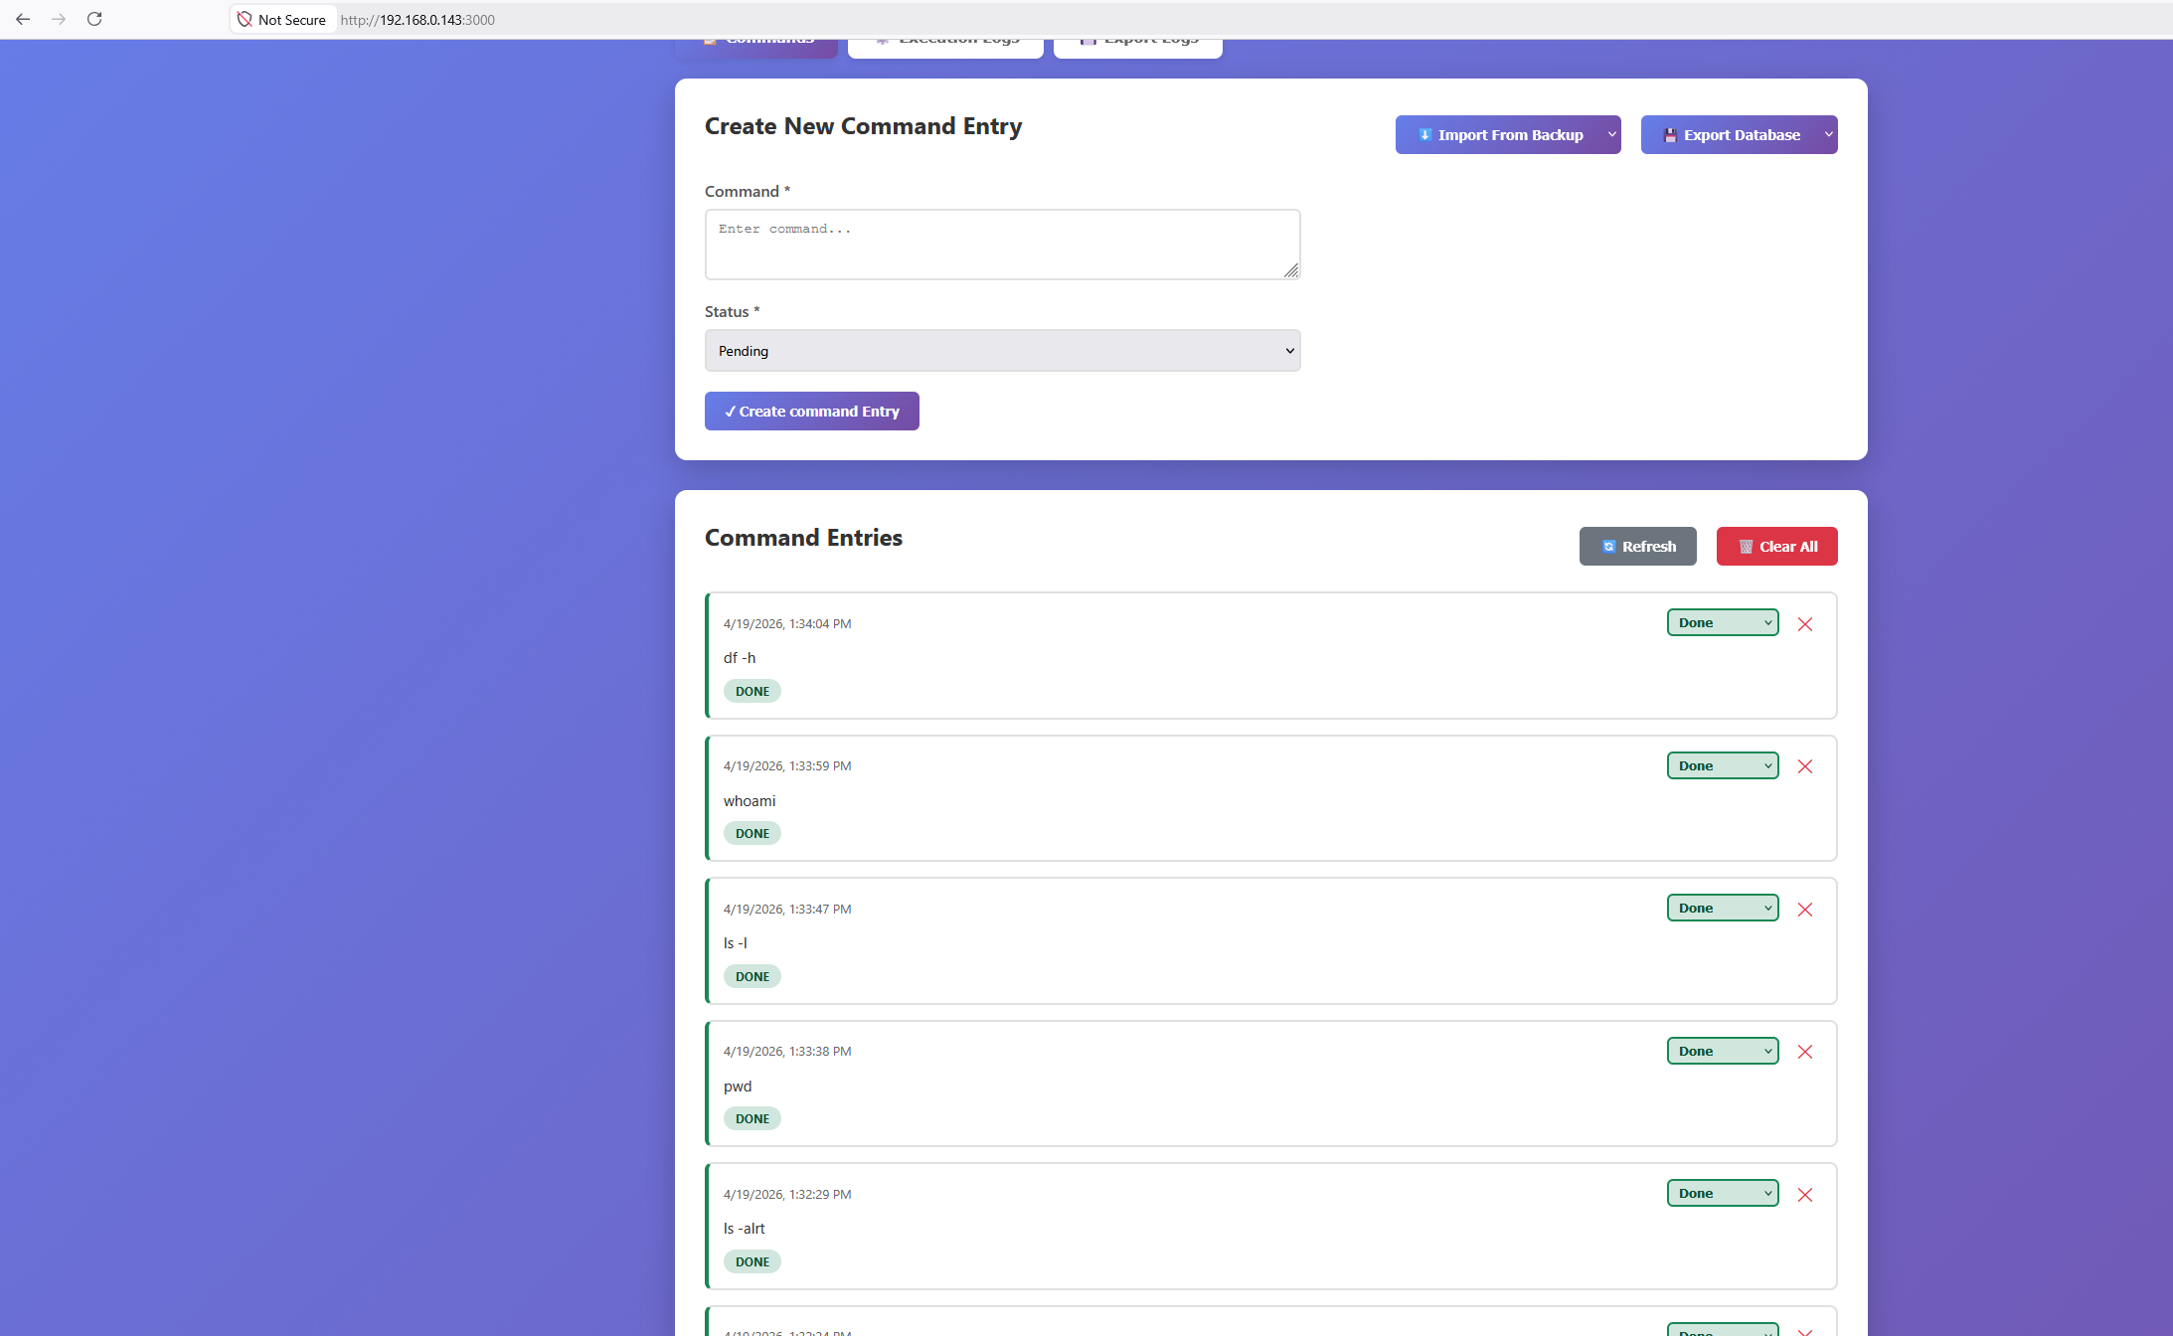
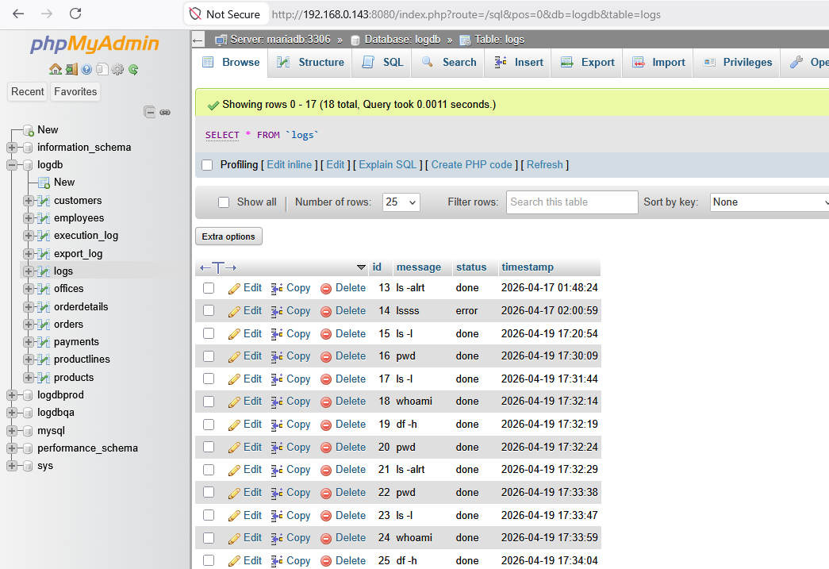
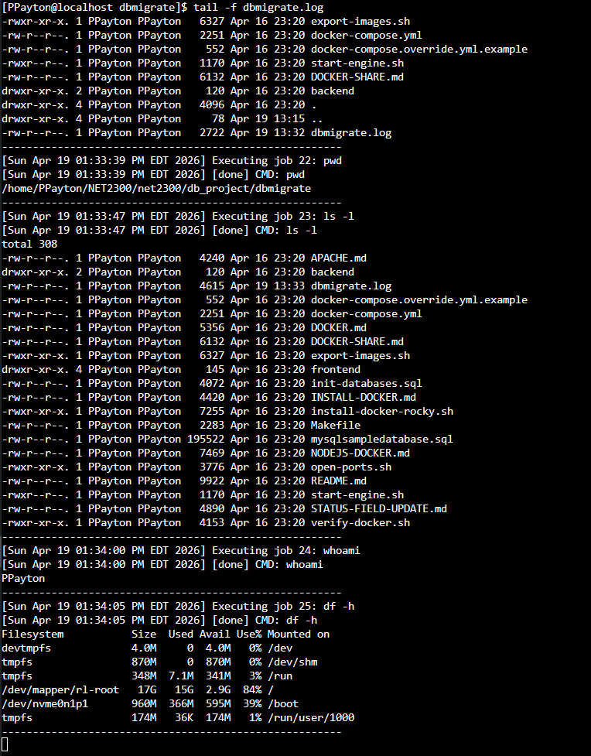

Issue several wrong Linux commands:
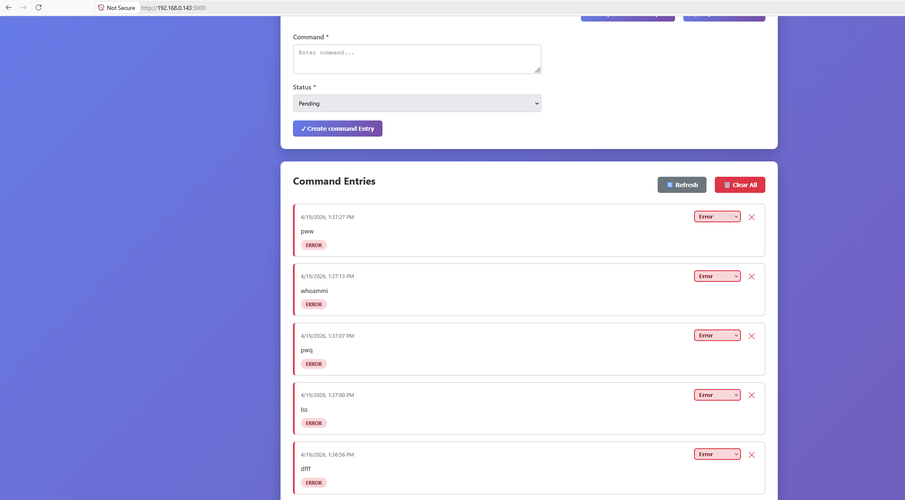
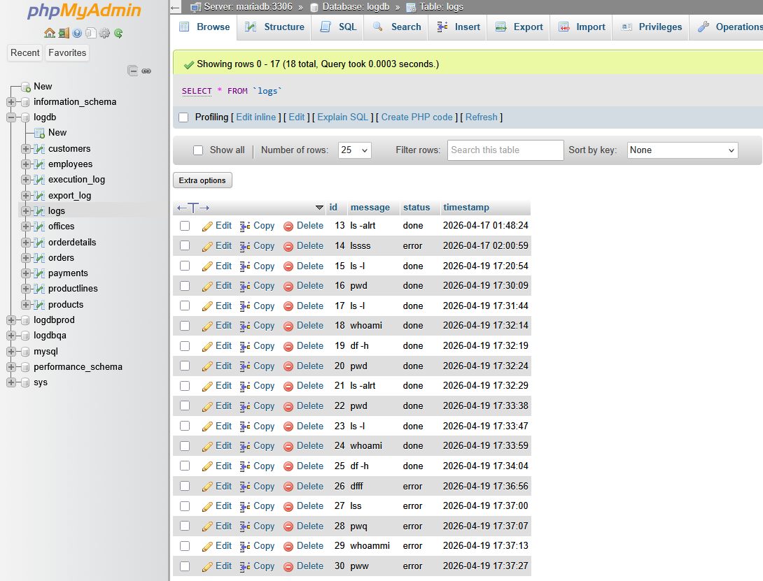
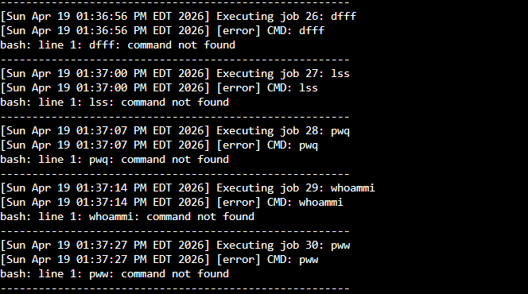
Execution_log table entries:
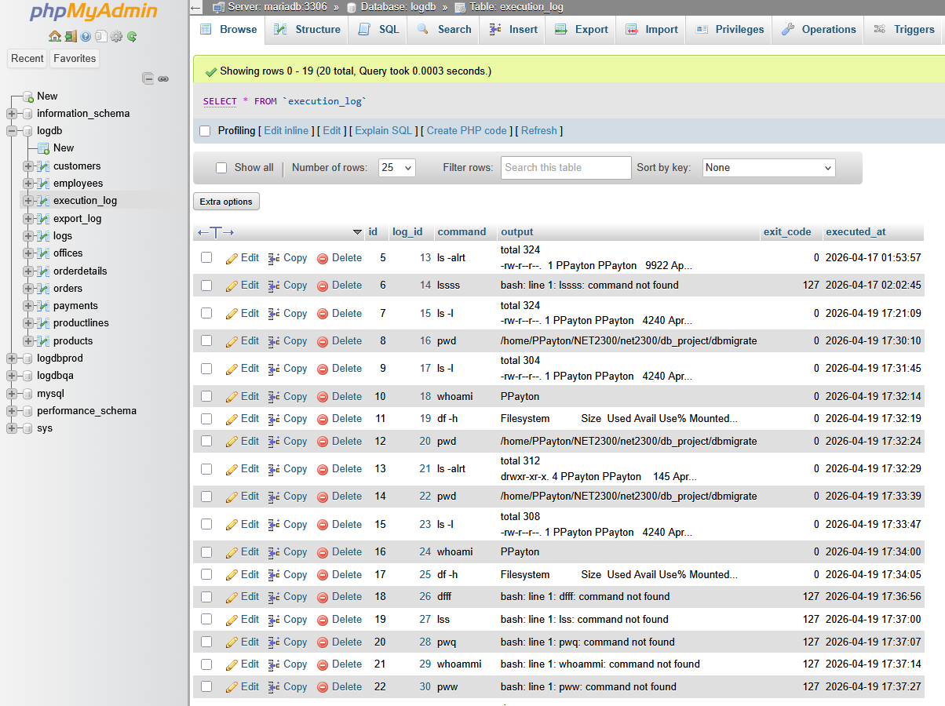
Dblogrotate.sh script:
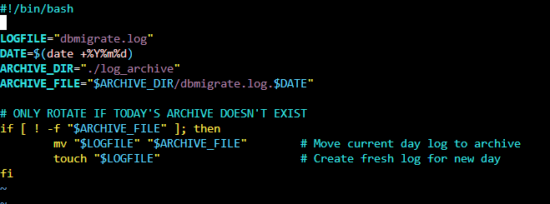
Test Run:
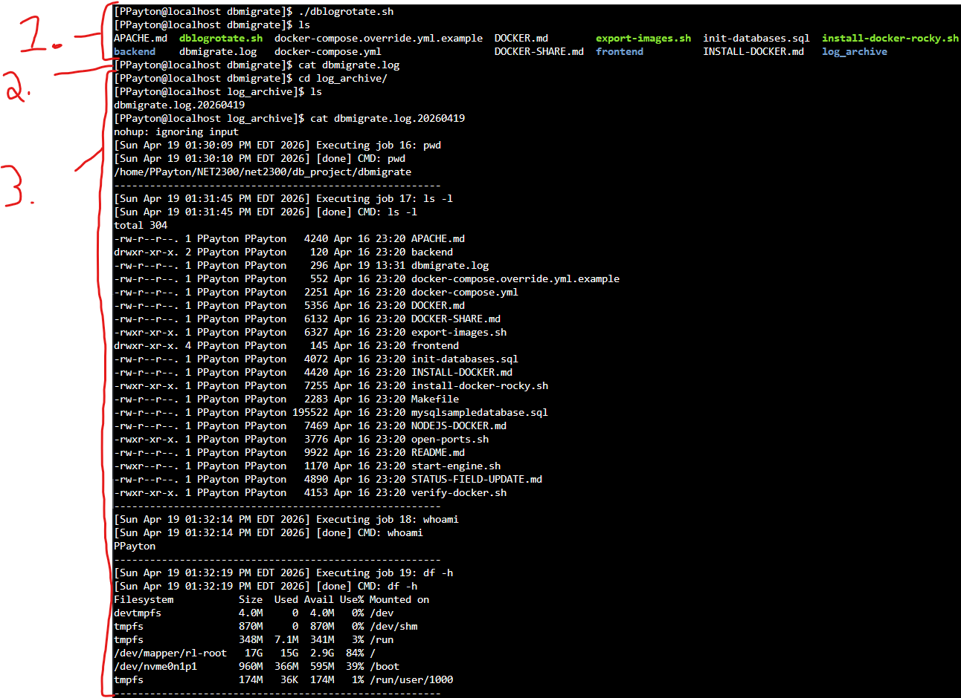
1. Run dblogrotate.sh script, ls to see new dbmigrate.log file in directory.
2. cat dbmigrate.log to confirm it is blank and ready for new day of entries (cat returned nothing)
3. Switch to log archive directory, confirm creation of archived log, and confirm contents of the day were written to the archive log file.
Rotate dbmigrate.log at midnight every night (crontab):
